**UNIVERSITY OF ZIMBABWE**



***Bridging the gap between university education and industry***

***Industrial attachment report submitted***

**By**

**CASPER MARINGE (R187966Q)**

**In partial fulfilment of the requirements of Bachelor of Science Honours**

**in**

**Actuarial Science Degree**

**For the Period**

**01 November 2021 – 31 JULY 2022**

STUDENT DETAILS

**NAME: CASPER MARINGE**

**REG NUMBER: R187966Q**

**PROGRAMME: BACHELOR OF SCIENCE HONOURS IN ACTUARIAL SCIENCE (HASC)**

**YEAR: 3 (THIRD YEAR)**

**COURSE: HASC (380)**

**INSTITUTION: UNIVERSITY OF ZIMBABWE**

**NAME OF COMPANY: POSCLOUD (PRIVATE) LIMITED**

**DEPARTMENT: DATA SCIENCE, FINANCE AND ACCOUNTING AND BUSINNESS DEVELOPMENT**

**INDUSTRIAL SUPERVISOR: MR V.O NKOMO**

**ACADEMIC SUPERVISOR: MR MUPEDZA**

**PERIOD OF ATTACHMENT: 01 NOVEMBER 2021 – 31 JULY 2022**

Preface

For nine months from November 2021 till July 2022, the student carried out an internship programme at Poscloud (Private) Limited, a Financial Technology company which focuses on developing payment gateways, data analytics, real time monitoring, managing payroll, time control software and hardware, amongst other software solutions. Poscloud is located at S’matsatsa Office Park, along Borrowdale Road in Harare.

This report serves as a partial fulfilment of the HASC 308 internship program, in this internship report the student will describe his experiences during this internship period, the purpose of an industrial internship is to bridge the gap between theories and principles learnt during the students’ first two years at the institute and practical aspects of the degree programme. It exposes the student to the kind of environment that they will operate in when they eventually graduate and get permanent employment on the job market. This report contains an overview of the company of internship, the activities, tasks assigned and projects that the student worked on during internship.

It also provides a synthesis of theoretical approaches learnt and methods of implementing them in the business world, which is the relationship between theoretical and practical knowledge. An elaboration on the future works which can be persuaded as an advancement of the current work is also incorporated in this report. Due to limitations, shortcomings and successes that the student faced, in this report there shall be some recommendations and comments on the internship program.

**Acknowledgements**

Special regards go to the University of Zimbabwe through the faculty of science and department of Mathematics and Computational Sciences. Student would like to thank the supervisor, Mr Mupedza, for the patient guidance, encouragement and advice he has provided over the time.

The student would also like to acknowledge his industrial supervisor Mr Nkomo for diligently guiding him and mentoring him on how to be effective in the work environment. He made it easy for the student to improve by teaching and training him in various areas of interest.

The student wishes to acknowledge the support and great love of his family and friends, not forgetting his managing director, Mr Zhakata for awarding him the opportunity to be part of the Poscloud Team. They kept the author going on and this work would not have been possible without their input. It is whole-heartedly appreciated that their great advice for the author’s internship proved monumental towards the success of this internship program.

**Executive Summary**

This report summarizes the nine-months long internship program that the student successfully completed at Poscloud (Private) limited in the Data Science consultancy department, Finance and Accounting department and Business Development department as a requirement of the Bachelor of Science Honours degree in Actuarial Science.

The report will mainly focus on giving a review on Poscloud in regards to their stated vision and mission statement, it will also go on to state the relevance of the industrial attachment and how they were applied in the real business environment among other things. It also focuses on assessing the work that the student carried out, evaluate the relevance of the student’s working experience and the practical experience acquired, assesses the problems encountered and solutions implemented and also provides conclusions and recommendations to both the school and the organization based on findings during internship.

During the student’s nine months at Poscloud he worked with the data scientist performing big data analytics which involved dealing with more than 10 million rows of data gaining more insights on the data so that the extracted information will be used by other non-technical staff in in the business development department, in data science department, certified financial analyst and accountants in cash flow projections, bank reconciliations and other financial aspects in finance and accounting department and he also worked with business strategist in implementing new business strategy in business development which is in business development department. The student in his report gives a detailed account on the specific work that he did and tasks he fulfilled.

The student learnt to build a good rapport with his colleagues and trained himself to communicate confidently with authorities and clients. He also managed to gain valuable knowledge through active participation and inquisitive learning. The report goes on to give an account on the student’s internship programme and how it impacted on the student’s aptitude in various fields which include team work, report writing and even presentation. In conclusion, this Industrial attachment had highly supplemented in the world of ‘FinTech’. It was undoubtedly a beneficial and educating experience for the student.

**LIST OF ABBREVIATIONS**

**Abbreviation Meaning**

EDA Exploratory Data analytics

SQL Structured Query Language

UZ University of Zimbabwe

R Statistics programming language

POP Proof of payments

PCA Principal Component analysis

KNN K Nearest Neighbors

TS TensorFlow package for Artificial Intelligence

DC Data Cleansing

ML Machine Learning

DL Deep learning

AI Artificial Intelligence

RM Risk Management

IL Inductive learning

CPI Consumer Price Index

HR Human Resource

TABLE OF CONTENTS

1 INTRODUCTORY CHAPTER 10

1.1 Introduction 10

1.2 Company background 11

1.3 Company Location 11

1.4 Company Vision, Mission & Values 11

1.4.1 Vision 11

1.4.2 Mission 12

1.4.3 Core Values 12

1.5 Poscloud (Private) Limited’s Organisational structure 12

1.6 Overview of the departments 13

1.6.1 Data Science 13

1.6.2 Finance and Accounting 13

1.6.3 Human resource Management (HR) 14

1.6.4 Business Development 15

1.6.5 Hardware and Support 15

1.6.6 IT and Software Development 16

1.6.7 Networking 16

2 NATURE OF INDUSTRY 16

2.1 Introduction 16

2.2 POS Device Supply and management 17

2.3 Merchant Hosting 17

2.4 Custom Software Development 18

2.5 Near Field Communication 18

2.6 Postillion System 18

2.7 Data Analytics 19

2.8 Real-time Monitoring 19

2.9 Payroll Services 19

2.10 24/7 Support 20

3 COMMERCIAL ENVIRONMENT OF Poscloud (Private) Limited. 20

3.1 POSCLOUD PARTNERS 21

3.1.1 NMB BANK LIMITED 21

3.1.2 CBZ BANK LIMITED 21

3.1.3 TREK PETROLEUM 21

3.1.4 ZUPCO TAPCARD ZIMBABWE 21

3.1.5 FBC BANK ZIMBABWE 22

3.2 RANGE OF DEVICES OFFERED BY POSCLOUD TO BANKING AND NON-BANKING INSTITUTIONS. 22

**3.2.1** **RANGE OF DEVICES** 23

**3.3** **THE AREA THE STUDENT WAS ATTACHED TO WITHIN THE ORGANISATION** 25

3.3.1 Departments which the student was attached to were: 25

3.3.2 THE OBJECTIVES OF THE ATTACHMENT: 25

4 THE TECHINICAL SECTION 25

4.1 INTRODUCTION 25

4.2 TRAININGS UNDERTAKEN AND THE INTERN’S RELATIONSHIP WITH THE COMPANY 26

4.2.1 Induction training 26

4.2.2 HOW TO PERFORM DATA ENGINEERING TRAINING 26

4.2.3 DATABASE CONCEPTS AND SQL 26

4.2.4 INTRODUCTION TO STRUCTURED QUERY LANGUAGE (SQL) 26

4.2.5 WHAT EXPLORATORY DATA ANALYTICS (EDA) IS? 27

4.2.6 MACHINE LEARNING CONCEPTS 27

4.2.7 INTRODUCTION TO BIG DATA ANALYTICS 28

4.2.8 HOW TO USE ANALYTICAL TOOLS 28

5 PROJECTS THE AUTHOR WORKED ON 28

5.1 INTRODUCTION 28

5.2 DATA SCIENCE DEPARTMENT 29

5.2.1 Step1 29

5.2.2 Step2 29

5.2.3 Step 3 30

5.2.4 Step 4 31

5.2.5 Step 5 31

5.3 FINANCE AND ACCOUNTING DEPARTMENT 32

5.3.1 BANK RECONILLIATIONS 32

5.3.2 CASHFLOW PROJECTIONS 33

5.4 BUSINESS DEVELOPMENT DEPARTMENT 33

6 CHALLENGES AND PERSONAL DEVELOPMENT 33

6.1 INTRODUCTION 33

6.2 CHALLENGES AND SOLUTIONS 33

6.2.1 Tight deadlines 34

6.2.2 Solution 34

6.3 BENEFITS TO THE STUDENT 34

6.3.1 Teamwork and Networking 34

6.3.2 Etiquette and grooming: 34

6.3.3 Time management: 34

6.3.4 Accountability 35

6.3.5 Communication 35

6.3.6 Drive and Resilience 35

6.3.7 Confidence 35

6.3.8 Ability to deal with confidential information 35

6.3.9 Responsibility: 35

6.3.10 Prioritisation 36

6.4 BENEFITS TO THE HOST COMPANY 36

6.4.1 VALUE ADDITION 36

6.4.2 Real time monitoring of company finances 36

6.4.3 Mitigating risks associated with fintech industries 36

6.4.4 Business Focus 36

7 EXPECTATIONS VS INDUSTRIAL REALITY 37

7.1 Introduction 37

7.2 Conclusion 37

8 RECOMMENDATIONS TO IMPROVE THE INDUSTRIAL ATTACHMENT PROGRAM 37

8.1 INTRODUCTION 37

8.2 TO POSCLOUD 38

8.2.1 Communication 38

8.2.2 Employee Log Book 38

8.2.3 Need for a Testing and Quality Assurance Team 38

8.3 Recommendations to the University 38

8.3.1 Attachment reports. 39

8.3.2 Pre-attachment preparations 39

9 CONCLUSION 39

10 LIST OF REFERENCES 40

Table of Figures

Figure 1 company location 11

Figure 2 Poscloud organogram 13

Figure 3 device supply management 17

Figure 4 Custom software supply 18

Figure 6 Data analytics 19

Figure 7 Real time monitoring 20

Figure 8 24/7 Support 20

Figure 9 Payroll 21

Figure 10 NMB log 21

Figure 11 CBZ log 22

Figure 12 TREK PETROLEUM LOG 22

Figure 13 FBC log 22

Figure 14 ZUVA log 23

Figure 15 Aisino devices 23

Figure 16 Range of devices 24

Figure 17 Gathering Data 31

Figure 18 Exploratory Data analytics 32

Figure 19 Forecasting 33

Figure 20 SQL 33

Figure 21 DASHBOARD 1 34

Figure 22 DASHBOARD 2 34

# INTRODUCTORY CHAPTER

## Introduction

This chapter is devoted to the enlightenment of Poscloud (Private) limited operations, background, inter alia its organogram, various departments that make up the organisation. Poscloud is one of the giants in the FinTech industry in Zimbabwe. It has of late surged to be the leading player in the payment gateways industries within and beyond Zimbabwe’s boarders.

## Company background

Poscloud is a wholly owned Zimbabwean Financial Technology company that specializes in the provision of hardware and software solutions for both banking and non-banking institutions. The company operations commenced on the 1st of July 2017 and by the 1st of November 2017, its transactions went live. Poscloud has an exclusive distributorship agreement with Vanstone Electronics (Beijing)Co. Limited, a State-Owned Chinese Company listed on the Shanghai Stock Exchange that manufactures Aisino branded Point of Sale devices.

## Company Location

*Smatsatsa office park along Borrowdale road*

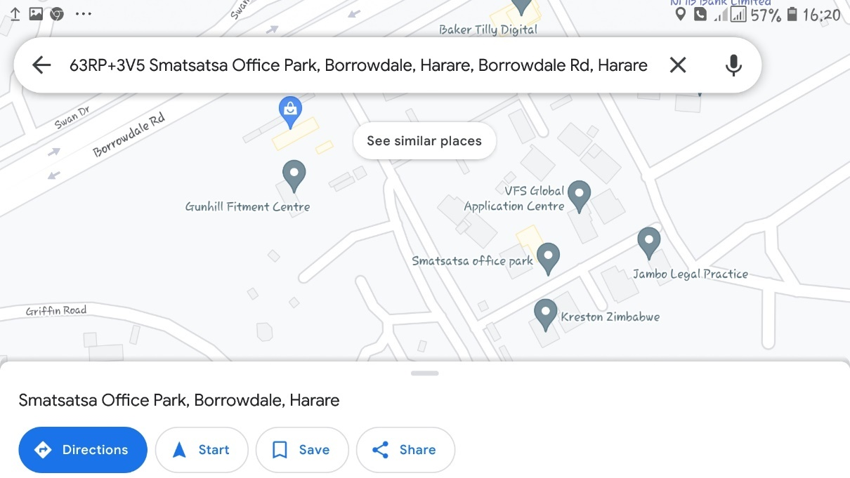

Figure 1 company location

## Company Vision, Mission & Values

### Vision

The company vision is to become the leading FinTech company in Southern Africa by leveraging their exclusive international partnerships to bridge the gap between financial institutions and the public through offering adaptive, intuitive and cost-effective payment solution technologies.

### Mission

To become one of the world’s leading innovators in the financial technology space enabling banks and non-banking institutions to realise their full potential.

### Core Values

In pursuit of its vision and mission, Poscloud upholds the following principles and core values:

* Simple
* Swift
* Secure
* ***Excellence,*** we exceed shareholder expectations and uphold and execute principles of high-performance delivery and continuous improvement.
* ***Professionalism,*** we perform our work with expertise and dedication.
* ***Integrity,*** we are ethical honourable and transparent.
* ***Innovation,*** we meet the changing needs of our industry and market.

## Poscloud (Private) Limited’s Organisational structure

The organogram below clearly shows the level of management and unit of command in Poscloud (Private) Limited. Poscloud has 7 distinctive departments as shown by the organogram, 3 of these departments report to the (CTO) chief Technology officer, who then reports to the Chief Operations Officer, who finally reports to the Chief Executive Officer and he has the overall voice in Poscloud.

Figure 2 Poscloud organogram

## Overview of the departments

### Data Science

As Poscloud is a fintech company, the data science department plays a vital role in overseeing data management activities at Poscloud, performing:

* Data analytics for structured and unstructured data,
* Data engineering.
* Monitoring Poscloud servers and software.
* Data analytics consultancy.
* Creating Machine Learning models (ML) and Artificial intelligence (AI).
* Business development activities, by giving insights of the performance of the company so that management can make well informed business decisions.

### Finance and Accounting

This department deals with:

* payment processing
* Creating financial year budgets for the company as a whole and then per each department.
* Reconciliation of accounts and production of financial reports.
* Assessment of financial viability.
* Cash flow projections
* Processing payments inclusive of staff salaries.
* Safe kееping of the bank’s assets by designing, implementing, maintaining and continual assessments of the bank’s internal controls.
* Establishment of financial and administrative policies and procedures.
* Tax reporting and compliance
* Financial auditing.

### Human resource Management (HR)

A distinctive approach to employment management which seeks to achieve a competitive advantage through the strategic development of a highly competent workforce using an integrated array of cultural, structural and personnel techniques. The Human Resources department has the responsibility for coordinating other departments by providing support whilst carrying out functions like employee management, facilities and housekeeping. The human resources department is focused on providing support to other departments hence helping in the proper running of the organization in all aspects.

Roles of the Human Resources Department:

* Recruitment and Selection
* Induction and orientation of new employs to their relevant departments of the company. Personnel manning and this includes making sure that respective sections of the bank have adequate personnel at the right time and at the right place.
* Remuneration and compensation of existing and out-going employs.
* This usually includes pension fund administration.
* Discipline and dismissal of workers who may have gone parallel to the company code of conduct. Safety, healthy and staff welfare.
* Industrial relations.

### Business Development

Its members are responsible for a number of key objectives inside and outside the organization. They study the products, services and operations of companies, providing consultative help where needed.

* Developing and sustaining solid relationships with company stakeholders and customers.
* Analysing customer feedback data to determine whether customers are satisfied with company products and services.
* Recruiting, training, and guiding business development staff.
* Providing insight into product development and competitive positioning.
* Analysing financial data and developing effective strategies to reduce business costs and increase company profits.
* Conducting market research to identify new business opportunities.
* Collaborating with company executives to determine the most viable, cost-effective approach to pursue new business opportunities.
* Meeting with potential investors to present company offerings and negotiate business deals.

### Hardware and Support

Software support is a range of customer services to assist customers in making cost effective and correct use of a product. Software support consists of online support, walk in client support and road support. It includes assistance in planning, installation, training, troubleshooting, maintenance, upgrading, and disposal of a product. Typical job responsibilities include:

* Communicating with clients and customers about their experiences with a product or service.
* Visiting clients’ premises to provide our services.
* Providing advice on purchasing products or services.
* Answering client or customer questions about properly using or accessing a product or service.
* Taking or processing orders for a product or service.
* Listening to customer or client complaints or concerns and working to resolve their issues.
* Software installations and training.
* Poscloud product update functionality testing.

### IT and Software Development

They are responsible for the design, testing and maintenance of software programs for computer operating systems or applications. This department is generally responsible for the development, design and implementation of new or modified software products or ongoing business projects. Typically sitting within the IT team of a business, a Software Developer will be involved in liaising with the Business Analysts and Development Managers to ensure software projects meet requirements.

* Researching, designing, implementing and managing software programs.
* Testing and evaluating new programs.
* Identifying areas for modification in existing programs and subsequently developing these modifications.
* Writing and implementing efficient code.
* Determining operational practicality.
* Developing quality assurance procedures.
* Deploying software tools, processes and metrics.
* Maintaining and upgrading existing systems.
* Working closely with other developers, UX designers, business and systems analysts in the support department.

### Networking

This department oversees the overall network of the organisation. It oversees the distribution of computer software and hardware within the company and is responsible for its maintenance. The duties of this department include:

* Securing the organisation’s network and making sure it’s not prone to attacks from the outside and hackers by using firewalls to protect the network system.
* Maintaining the Poscloud local server as well as the cloud server.
* Configuring and wiring of network cables and routers.

# NATURE OF INDUSTRY

## Introduction

Poscloud (Private) Limited is a financial technology firm and provides a range of software products and services to banking and non-banking institution.

The products and services offered are:

* POS Device Supply and management
* Merchant Hosting
* Custom Software Development
* Near Field Communication
* Postilion System
* Data Analytics
* Real-Time Monitoring
* 24/7Support
* Payroll Services

## POS Device Supply and management



Figure 3 device supply management

* Poscloud has an exclusive distributorship agreement with Vanstone Electronics (Beijing) Co. Limited, a State-Owned Chinese Company listed on the Shanghai Stock Exchange that manufactures Aisino branded Point of Sale devices. Our team is trained to provide after sale POS device support, repair and maintenance.

## Merchant Hosting

* 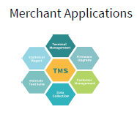 Poscloud provides several interfaces for developing custom-built payment platforms that will allow our clients to accept payments in real-time from their secure server and have complete control over their payment page, without having to redirect their customers to a Hosted Payment Page.

## Custom Software Development



Figure 4 Custom software supply

* Poscloud designs and builds software solutions to address unique needs for its clients.
* With vast experience in IT, Poscloud provides all-round custom software development services to deploy highly customized software with speed and quality.

## Near Field Communication

Poscloud offers Near Field Communication services. Near Field Communication (NFC) is a set of short-range wireless technologies, typically requiring a distance of 4cm or less to

Figure 5 Near field communication

initiate a connection. Poscloud NFC services are currently being offered through an offline prepaid card (TapCard) facility. The card is currently being used by CBZ and NMB

for ZUPCO & ZINARA.

## Postillion System

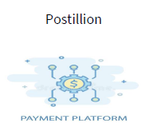

* Poscloud’s Postillion system, “Pay 263” is a system that provides banking transaction switching software that routes financial transactions.
* Our Postilion switch software servers are set up in a relatively simple fashion, whereby transactions flow into the switch, which then sends them through to their appropriate destination.

## Data Analytics

* At Poscloud we help clients make the right sense of data while tracking the effectiveness of their processes and strategies, & measuring performance. Our data management & analytic capabilities and research skills bring together context and data to generate meaningful business insights. We are one of the leading data analytic consulting services companies

Figure 6 Data analytics

offering marketing analytic, customer analytic, research analytic, sales analytics, and other

data analytic services

## Real-time Monitoring



Figure 7 Real time monitoring

To enable us to respond to problems right away, Poscloud uses real-time monitoring

tools. By tracking real-time monitoring data over time, our clients can reveal and predict

trends and performance. The data also helps to adjust resources if needed based on traffic.

## Payroll Services

* Wage Cloud is an automated payroll management system designed to make payroll processing easier, faster and more secure. It offers comprehensive human resource management, statutory reports calculations, compliance, leave management.
* The payroll module for Poscloud is the one responsible for the process of paying employees, keeping employee’s records for an organisation as well as filling employment taxes. Poscloud Payroll is focused on helping you to bring efficiency and full control into your payroll and workforce management functions.
* Poscloud payroll helps eliminate errors and delays in processing your Payroll and HR requirements. Poscloud Payroll includes all of the necessary reports required by the statutory bodies such and pension funds for submission on a periodic basis – all you need to do is print or email the report. Poscloud has comprehensive tax display with a full breakdown of the PAYE and FDS calculations. Some of the statutory bodies such as ZIMRA and NEC uses Poscloud Payroll to pay their own employees.

Figure 9 Payroll

## 24/7 Support

* Poscloud offers 24hour support services through the Help-desk where issues can be logged at any time. Turnaround time for issues is 2 hours maximum. Also, Data Scientist developed an algorithm which can interact with our clients as a bot robot using Artificial intelligence (AI). So that our clients can be helped at any time our clients’ including weekends, also recommends us as a service provider of your choice.

Figure 8 24/7 Support

# COMMERCIAL ENVIRONMENT OF Poscloud (Private) Limited.

* Poscloud has an exclusive distributorship agreement with Vanstone Electronics (Beijing) Co. Limited, a State-Owned Chinese Company listed on the Shanghai Stock Exchange that manufactures Aisino branded Point of sale devices. <https://www.vanstone.com.cn/en/aboutvanstone?name=CompanyIntroduction>

## POSCLOUD PARTNERS

### NMB BANK LIMITED

* NMB Bank Limited and PosCloud (Private) Limited have signed a Memorandum of Agreement for Agency and Merchant Support Services with NMB Bank Limited. To date, Poscloud has delivered over 10 000 active devices to NMB which have processed transactions valued at over ZWL$35 billion.

Figure 10 NMB log

### CBZ BANK LIMITED

* CBZ Bank Limited and PosCloud (Private) Limited have signed a Memorandum of Agreement for Merchant Support Services with CBZ Bank Limited. To date, Poscloud has delivered over 8000 Point of Sale devices to CBZ which have facilitated transactions valued in the region of ZWL$6 billion.

Figure 11 CBZ log

### TREK PETROLEUM

* Bionest Investments T/A Trek Zimbabwe have signed a Memorandum of Agreement for a card and smart-pos based fuel management system. Additionally, Poscloud developed the Agro-Yield software system to assist Bionest in resource allocation to farmers across Zimbabwe.

Figure 12 TREK PETROLEUM LOG

### ZUPCO TAPCARD ZIMBABWE

* TapCard Zimbabwe -Poscloud deployed an offline NFC based payments system which currently has over 00,000 card holders and this system is currently in use on ZUPCO buses and at various tollgates in the Country. CBZ and NMB are currently making use of this solution.

### FBC BANK ZIMBABWE

Poscloud and FBC Bank have recently entered into a Partnership Agreement for the deployment of Integrated Point of Sale Devices, staff training and other after sales support services.

Figure 13 FBC log

## RANGE OF DEVICES OFFERED BY POSCLOUD TO BANKING AND NON-BANKING INSTITUTIONS.

**Poscloud distributes state-of-the-art POS devices**



Figure 15 Aisino devices

### **RANGE OF DEVICES**

``````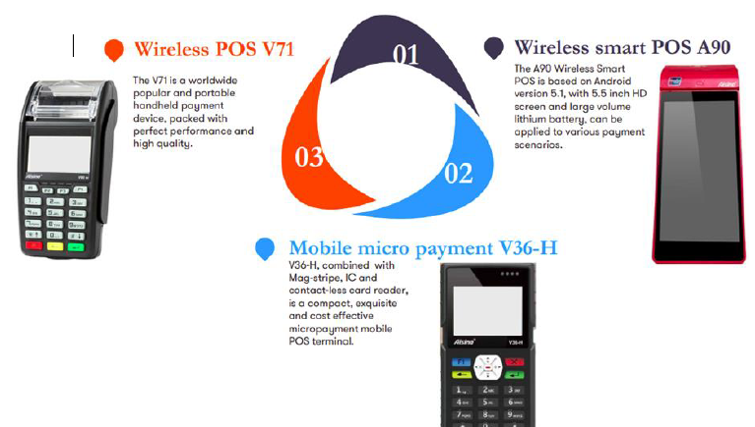

Figure 16 Range of devices

#### **Wireless Handled POS-V71**

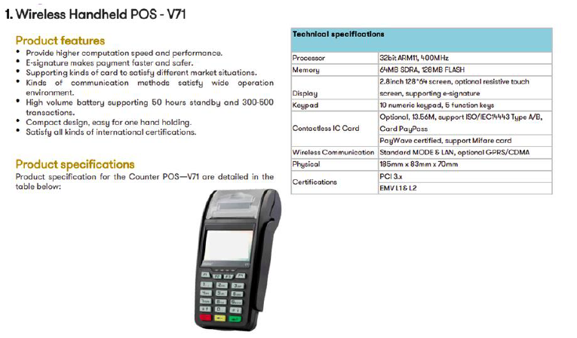

#### **Mobile Micropayment POS-V36-H**

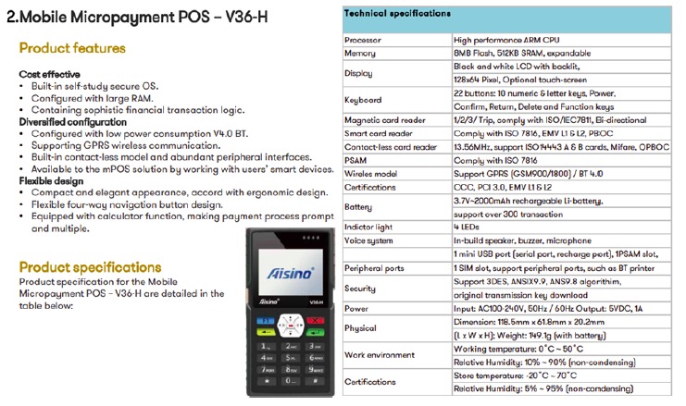

#### **Wireless Smart Android POS-A90**

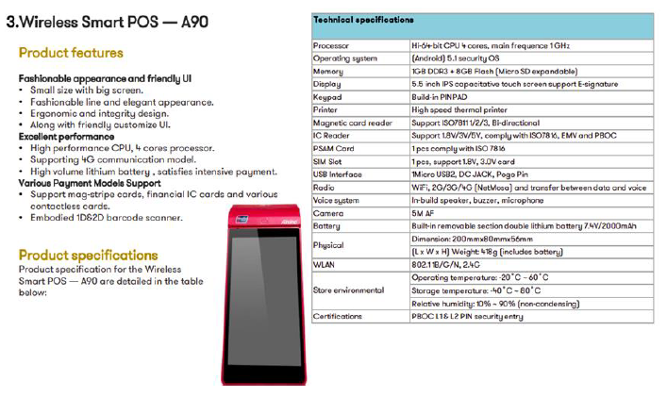

#### **Intergrated POS-V37**

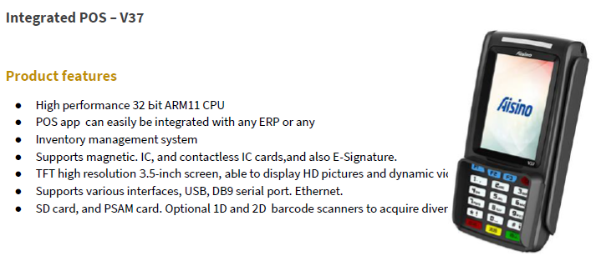

## **THE AREA THE STUDENT WAS ATTACHED TO WITHIN THE ORGANISATION**

The author was attached in multiple departments of the organisation since he had some basic knowledge of how some of the departments were supposed to function.

### Departments which the student was attached to were:

* The Data Science Department,
* The Finance and Accounting Department
* The Business and Development Department

Even though the student spent much of his time in data science department he also had time to be working in finance and accounting department.

### THE OBJECTIVES OF THE ATTACHMENT:

* Was to well equip the student in the world of FinTech and to assist the student in becoming a technical actuarial data scientist.

# THE TECHINICAL SECTION

## INTRODUCTION

This chapter explores the student’s internship program plan, that is the description of the work station, name of departments in which he got training in during the whole of the internship period. It also gives a detailed outline of the various duties that he performed in the respective departments that he was attached to and highlights the relevance of these tasks to the Bachelor of Science and honours in Actuarial Science degree program.

## TRAININGS UNDERTAKEN AND THE INTERN’S RELATIONSHIP WITH THE COMPANY

The student received training in various aspects of his internship programme so as to be able to carry out his duties promptly and swiftly which include:

### Induction training

In the first two weeks of the internship programme the student went through heavy induction training and team building. At this training he was taught on the important take notes of Poscloud, was educated on how work is done at the company. This training included having him being taught on the company vision, mission statement and also the core values and how they all shape the company image as well as support the mission statement and vision. During this period the student was also informed on the rules of the organisation such as how one is expected to dress and also what is expected of one as an intern. At this training the student also went through team building whereby he was taught to work in a team and also how to make team work easy and fun while achieving their team goals.

### HOW TO PERFORM DATA ENGINEERING TRAINING

The student was taught how to work in a variety of settings to build systems that collect, manage, and convert raw data into usable information for data scientists and business analysts to interpret. His ultimate goal was to make data accessible so that Poscloud team can use it to evaluate and optimize their performance.

### DATABASE CONCEPTS AND SQL

The author was taught that database is a systematic collection of data. which supports electronic storage and manipulation of data. Databases makes data management easy.

Example Bank stores all of their transactions as data in the database for later use. And then those transactions can later on be fetched using the sql.

### INTRODUCTION TO STRUCTURED QUERY LANGUAGE (SQL)

A standardized programming language that is used to manage relational databases and perform various operations on the data in them.

SQL is used to communicate with a database. According to ANSI (American National Standards Institute), it is the standard language for relational database management systems. SQL statements are used to perform tasks such as update data on a database, or retrieve data from a database.

### WHAT EXPLORATORY DATA ANALYTICS (EDA) IS?

Exploratory Data Analysis refers to the critical process of performing initial investigations on data so as to discover patterns, to spot anomalies, to test hypothesis and to check assumptions with the help of summary statistics and graphical representations.

The student was taken through data manipulation and performing hypothesis testing process for structured data and unstructured data as this is the most crucial part in data analytics also the model accuracy depends on how well defined is the data set.

The author was taught how to perform PCA (Principal component analysis) on the real-world data set.

The goal of EDA is to allow data scientists to get deep insight into a data set and at the same time provide specific outcomes that a data scientist would want to extract from the data set.

#### Types of Exploratory Data Analysis the Author was taught about:

* Univariate Non-Graphical.
* Univariate Graphical.
* Multivariate Non-Graphical.
* Multivariate Graphical.

Exploratory Data Analysis (EDA) is the crucial process of using summary statistics and graphical representations to perform preliminary investigations on data in order to uncover patterns, detect anomalies, test hypotheses, and verify assumptions.

### MACHINE LEARNING CONCEPTS

The author was taught that Machine learning is a branch of artificial intelligence (AI) and computer science which focuses on the use of **data and algorithms** to imitate the way that humans learn, gradually improving its accuracy.

#### Types of Machine Learning

There are four types of machine learning:

* **Supervised learning**: (also called inductive learning) Training data includes desired outputs.  This is spam this is not, learning is supervised.
* **Unsupervised learning**: Training data does not include desired outputs. Example is clustering. It is hard to tell what is good learning and what is not.
* **Semi-supervised learning**: Training data includes a few desired outputs.
* **Reinforcement learning**: Rewards from a sequence of actions. AI types like it, it is the most ambitious type of learning.

#### **APPLICATION OF MACHINE LEARNING**

* **The student was introduced to the concepts of mitigating risks using machine learning**
* **Finance**: decide who to send what credit card offers to. Evaluation of risk on credit offers. How to decide where to invest money.
* **E-commerce**:  Predicting customer churn. Whether or not a transaction is fraudulent.
* **Credit risk assessment**.

### INTRODUCTION TO BIG DATA ANALYTICS

Big data refers to data sets that are too large or complex to be dealt with by traditional data-processing application software. Data with many fields offer greater statistical power, while data with higher complexity may lead to a higher false discovery rate.

As Poscloud deals with transactional databases and which also control 70% of CBZ, NMB and FBC transactions it processes above 1 million transactions per week which is a huge volume of data which needs data scientist who can handle big data. This was a necessity for the author to learn first.

### HOW TO USE ANALYTICAL TOOLS

1. Python
2. Tableau
3. Power BI
4. Anaconda
5. TensorFlow
6. Hadoop

# PROJECTS THE AUTHOR WORKED ON

## INTRODUCTION

Since the author worked in three different departments, he will mainly describe one major project he worked on in each department.

## DATA SCIENCE DEPARTMENT

In data science department that is where data analytics is done. This department mainly focused on the big data analytics using python, Hadoop, R, SQL and other statistical tools which can process big data.

The author worked on the monitoring system using (Grafana statistical monitoring tool, python jupyter from anaconda application, SQL, Hadoop and python Django rest framework) to track the financial transactions events that went through Poscloud for the NMB CBZ and FBC banks.

### Step1

The author gathered data from multiple databases using SQL, the author ended up having around 30 million of transactional rows which occurred in the period of January 2022 to March 2022

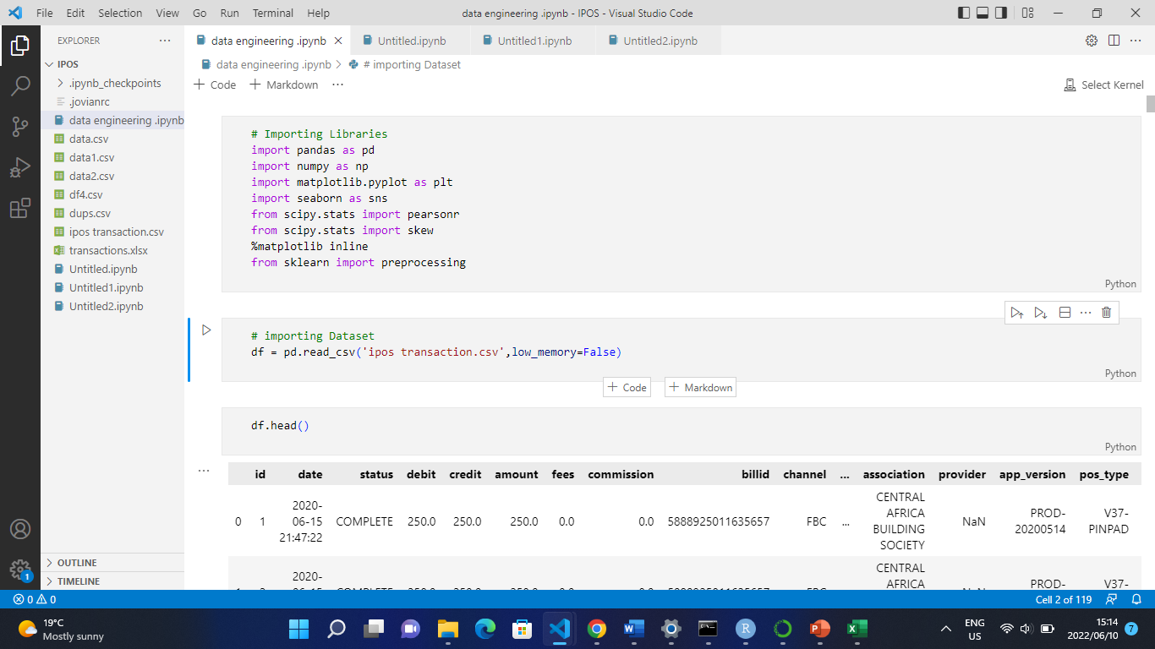

Figure 17 Gathering Data

### Step2

After this data engineering and data manipulations using SQL, the author then went on to perform EDA. Since this was a huge volume of data the author faced multiple challenges as his laptop was having a difficult in processing the data but luckily, he was given a new computer to perform this task.

He then gained more insight of the data he was dealing with and he did multiple linear regression performing PCA as shown below:

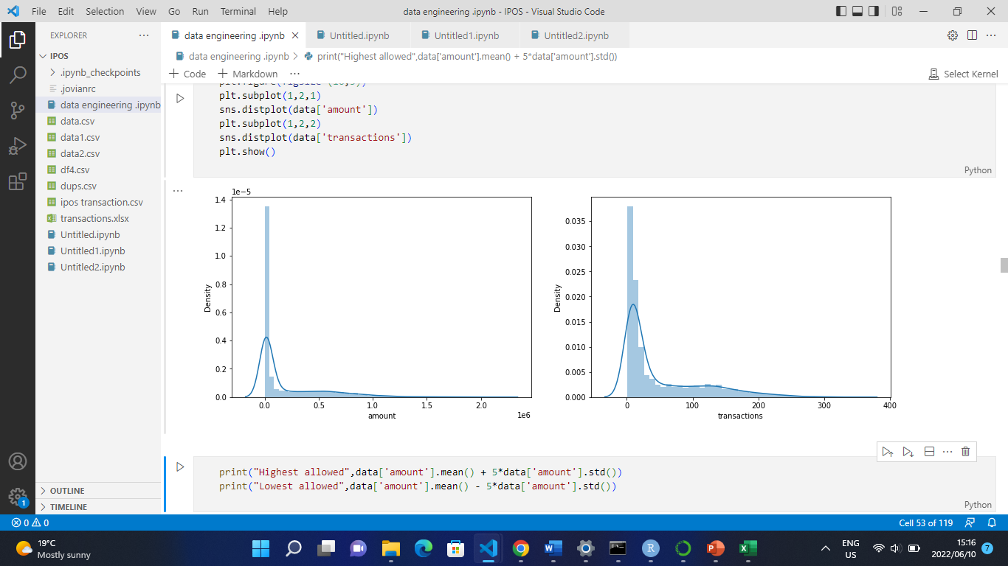

Figure 18 Exploratory Data analytics

### Step 3

After gaining more insight of the data the author then went on to build a Machine learning algorithm which can then predict the volume and value amount Poscloud was going to process in the near future.

The model had an accuracy of 82%.

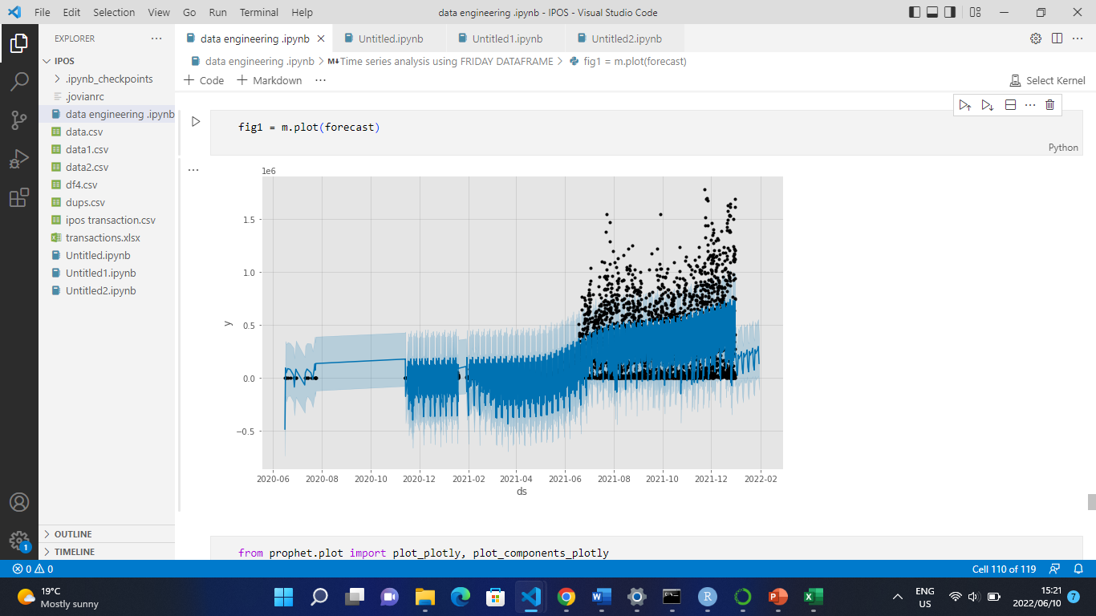

Figure 19 Forecasting

### Step 4

After building the algorithm using python the author then went on to create endpoints for the algorithm using python Django rest framework so that the results will then be later on implemented in the Grafana dashboard which can then later on be used to display results which can be interpreted by anyone without the data science technical experience as shown below

### Step 5

Then the author then went on building a dashboard for the results generated using the Grafana statistical monitoring platform which is easy to use

* but first the author had to connect the databases he used for the analysis in the Grafana dashboard
* He then went on to manipulate the data using SQL Prometheus Queries

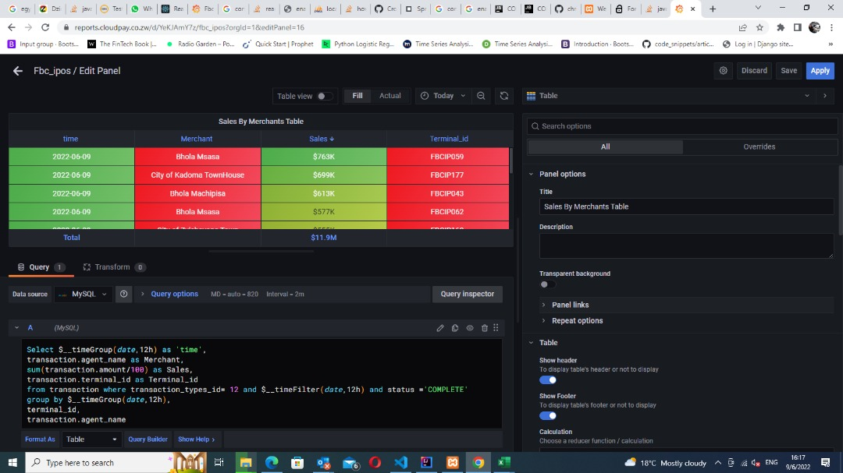

Figure 20 SQL

The end result of the dash board he created is as below.

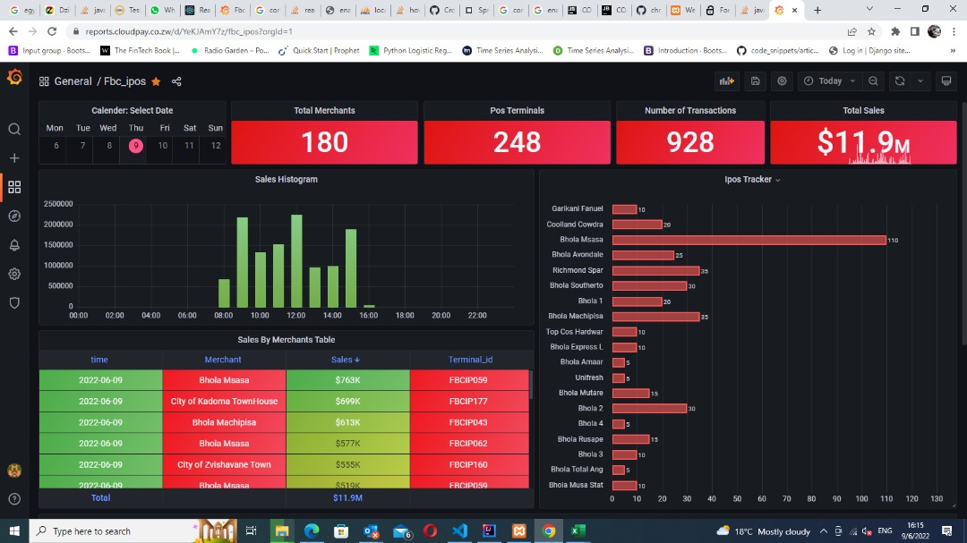

Figure 21 DASHBOARD 1

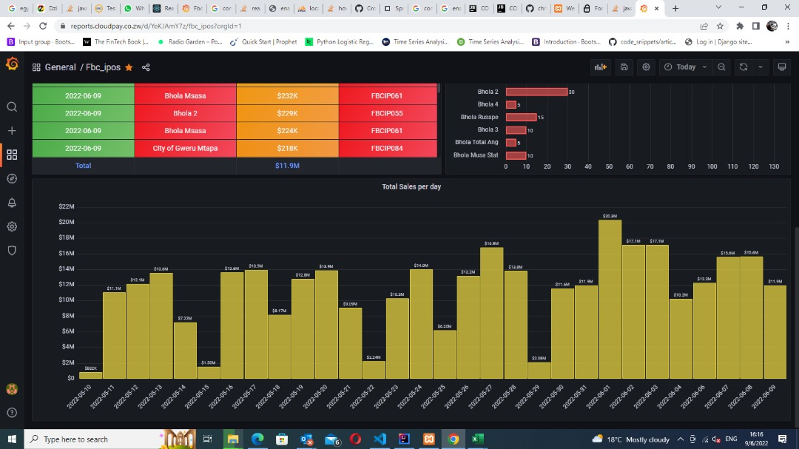

Figure 22 DASHBOARD 2

Up to this day this dashboard is being used at the FBC bank. It’s a real time monitoring platform.

And also, at Poscloud it is being used to monitor all Poscloud revenues as and from the day since this solution was implemented the Poscloud revenues have now gone up with around 20% as now Poscloud can easily see if there is an anomaly in the graphs and they could easily track the cause and get this fixed immediately.

At Poscloud, this project is considered as one of the best projects he did at Poscloud.

## FINANCE AND ACCOUNTING DEPARTMENT

In the finance and accounting the author worked on 2 major projects which were bank reconciliations and Cashflow projections.

### BANK RECONILLIATIONS

Since the author had some experience dealing with large volume of data he was of great help to the finance department as the accountants used to take up to 2 weeks to carry out a monthly recon as they had to breakdown large volume of data into multiple data sets so that they could perform bank reconciliations using Microsoft excel .

The author ended up only taking around an hour to perform bank reconciliations using python.

Then everything that had to do with reconciliations l was now the one who was handling it and this was a great experience for me given this responsibility.

### CASHFLOW PROJECTIONS

A cash flow projection estimates the money you expect to flow in and out of your business, including all of your income and expenses. Typically, most businesses' cash flow projections cover a 12-month period. However, your business can create a weekly, monthly, or semi-annual cash flow projection.

Since the author had basic knowledge of corporate finance he was asked to come in board with the team of financial analyst in the finance and accounting department so that he may broaden his knowledge of how corporate finance works in the real world.

The author worked on cash flow forecasting helping the team in building a more accurate model.

The author also had a chance to implement machine learning concepts in mitigating the risks associated with inflation.

## BUSINESS DEVELOPMENT DEPARTMENT

In the business development department, the author had a privilege to advice the business developers in way they can increase company revenues using the insights he gathered in the data analytics he carried out.

Also, the author had an opportunity come up with a strategy which can be used to increase the company production.

Basically, the author was an advisor to the board of the business development.

He had one of his strategy plans implemented which he can’t disclose in this report due to confidentiality.

# CHALLENGES AND PERSONAL DEVELOPMENT

## INTRODUCTION

This chapter will serve to highlight some areas where the trainee identified some shortcomings which might or are affecting the organisation. Possible solutions are to be highlighted also in this chapter. These solutions should come handy to be able to realize, effective and commendable performance or production of the organisation.

## CHALLENGES AND SOLUTIONS

### Tight deadlines

Due to having so many projects to be delivered there was always pressure on the need to have all projects released and solve all clients’ issues.

### Solution

The corrective method taken was always the need to prioritise the projects and client issues so as to make sure that the deadlines are met. Also, asking for assistance from my colleagues helped ensure I overcome this challenge.

## BENEFITS TO THE STUDENT

### Teamwork and Networking

Teamwork implies combining efforts of many people to achieve one common goal. In a setting involving groups and departmental interdependence, interaction and teamwork was key to seeing tasks through. The student learnt how to be respectful, understanding, tolerant and patient when working with others. Honesty and living one’s word smoothen all relationships, including work related ones. Networking was nurtured too in the process.

### Etiquette and grooming:

The student improved significantly on professionalism and developed exceptional

situation handling skills. Being constantly exposed to situations where one has to use

intuition and being given the autonomy to exercise action also stimulates confidence.

However, there are times when consultation was necessary and the supervisors are also welcome to assist.

The author learnt to apply (**theory to practice)**. The writer was able to relate concepts learnt to the reality in the business world. In a way, this will come in handy to the author in the fourth year of learning to respect such issues as accuracy and time management the same way they are required in practice.

### Time management:

Was key in ensuring that work was completed on time. The need to meet deadlines and timeous reporting upgraded the writer`s overall time management skills. The author learnt to be time mindful and to strike a balance between speed and accuracy. In doing the accounting degree the importance of time management is emphasized and this is also reflective in the field where deadlines have to be met hence you work speedily with great efficiency.

### Accountability

With respect to accountability the writer learnt to:

* Take full responsibility for own work and performance
* To query when and where necessary.
* Acknowledging how things could have been done

### Communication

It’s a tool used to establish understanding and people (colleagues, superiors, suppliers or customers) spend most of their time communicating, interacting and coordinating to get things done at the work place. Constant Interaction with a varied workforce and clients paid dividends as it improved my interpersonal skills.

### Drive and Resilience

I learnt to constantly remain calm and focused on key objectives and responsibilities given

by the superiors even under pressure. The ability to shake off pressure and challenges was

propagated and successfully became a part of the student.

### Confidence

The student is now capable of articulating his views confidently when communicating with

people from different backgrounds. The way that employees communicate with clients depicts the level of service excellence and therefore the strength of the brand.

### Ability to deal with confidential information

Most of the issues that the writer dealt with needed high levels of confidentiality, the likes of

financial reports among other sensitive organisational issues.

### Responsibility:

The industrial attachment imparted a responsible oriented mind in the student. With the organisation’s daily finance reporting section reporting relying entirely on the student, the student learnt to be responsible. The student learnt to be reliable doing every assigned task to the best of his abilities to make the company’s vision a reality.

### Prioritisation

The corporate environment is sometimes demanding hence required the student to rank tasks according to their importance. This implies that tasks that are considered urgent and important should be accomplished first followed by those which are urgent as well but of less importance.

In a nutshell, the attachment program effectively afforded the student an opportunity to:

* Learn about different work culture
* Establish industry networks and contacts
* Develop social soft skills as well as work-based skills
* Contribute to local telecommunication and mobile money industry
* Establish industry networks and contacts
* Develop social soft skills as well as work-based skills
* Learn about different work culture
* Find out what it's like to work in a potential career
* Gain valuable experience to build resume

## BENEFITS TO THE HOST COMPANY

The writer gave his level best for the success of the organization. Being goal oriented, work was esteemed to a level of undisputed priority. That, in one way or the other enriched on the success of the company.

### VALUE ADDITION

New ideas brought in starting from simple transaction processing to even high levels collectively improve and foster company growth and efficiency in operations.

### Real time monitoring of company finances

The student builds a monitoring system to track every financial aspect at Poscloud so as to easy access the position of the company at any time.

### Mitigating risks associated with fintech industries

The student advised on implementing strategies which can be used to mitigate risks that might occur in the future.

### Business Focus

The author built his understanding of the client’s business operating environment and controls in place to mitigate business risk. He also operated within the budgeted time frame.

# EXPECTATIONS VS INDUSTRIAL REALITY

## Introduction

The industry provides with an environment different to what the student expected. This chapter outlines the student’s expectations and the observed industrial realities

**Expectations vs Reality Table**

|  |  |
| --- | --- |
| **EXPECTATIONS** | **REALITY** |
| The student expected to be working in one department and only be engaged with the duties of that department. | The student was required to work and assist in all various departments even in ones he had no knowledge of. |
| The student expected to be guided through and through whilst doing the required tasks and get assistance as soon as they needed it. | After The trainings tasks were given and the student had to work on their own and figure out how to finish. |
| The student expected to work 8 hours from 8 am to 4pm and to not work during weekends. | The student worked for at least 9 hours from 8am to 5pm and was sometimes required to work during weekends |
| The student expected to work with colleagues as a team and provide ideas that can be implemented. | The student was able to work with a team of data scientists, risk managers, business developers and team work was experienced and the student’s ideas were also taken into considerations. |
|  |  |

## Conclusion

The expectations though not entirely fulfilled the reality provide with lessons and motivated hard work and commitment to the student’s work and the internship as a whole was not affected by this variance.

# RECOMMENDATIONS TO IMPROVE THE INDUSTRIAL ATTACHMENT PROGRAM

## INTRODUCTION

The student feels highly honoured to have had such impeccable time with the inspired family

(Poscloud). The organization has been performing remarkably with an amazing back up of excellent, innovative, professional, highly motivated, and diligent teams. The student extols the integrity, transparency and professionalism with which daily chores/commitments are undertaken. The author hereby humbly submits for the consideration of the Company a number of recommendations intended to add oil up the already performing company.

## TO POSCLOUD

### Communication

It’s a vital part and parcel of any organization, and Poscloud is no exception. The nature of

information varies considerably with some being perishable, thus requiring quick and timely

communication. Communication is responsible for the organizational success and guided

progress, as it motivates and directs employees accordingly. Communication in most

departments and subsequent sections need to be standardized and channels at the lower

levels more formalized to prevent the unfavourable grapevine dependence. Presently there is

use of email and telephone to give direction which is noble, but however inadequate and

therefore, requires perfection.

### Employee Log Book

The Company should consider putting in place an Internal Control System for the employees

aimed at managing their productive day time. This may come in handy in analysis of how

best employees can utilize their time.

### Need for a Testing and Quality Assurance Team

When I took part in the Connect version 2 development, I also recognized that as the company grows there is critical need for a software testing and quality assurance team. It was difficult for the current development team to undertake thorough system tests given the ongoing development that was happening. A separate team for testing and quality assurance will ensure all end-to-end, white-box and black-box tests are done thoroughly before launching any software product which therefore reduces the number of queries that will be posed to the development team once a product is out in the market.

## Recommendations to the University

As was highlighted earlier in the report, industrial attachment is crucial as it bridges the gap

between what was learnt and what takes place on the ground. It is in light of this very fact

that the reporter would like to express thanks to the University for presenting such a

program; it has been very worthwhile. Nevertheless, for the process to mutually benefit the

institute in the very same way it does to the student and the company there are some areas

that need to be addressed. The writer wishes to suggest the following areas for improvement

on the part of the University:

### Attachment reports.

A report being requested by the university on the 10 of June means that the report presented won’t detail all the work done by the student. The institution may address this by asking for reports near end of the attachment period. I therefore recommend that reports be submitted to the university at the end of the attachment period to effectively get a compressive and exhaustive report.

### Pre-attachment preparations

The University should set up more seminars specifically for students due for attachment to

equip and furnish them with the knowledge of the industry and insight on how they generally, have to work and present themselves. Industry based professionals may as well be invited to make some presentations.

* Proper learning and use of Statistical software and minimize the use of excel as it is rarely used in the industry.

# CONCLUSION

The Industrial attachment with Poscloud (Private) Limited has afforded me an opportunity to apply theory to practice and I worked hard to deliver what I have acquired to the best of my potential; therefore, the Industrial attachment was indeed an eye-opening exciting adventure.

This report is not exhaustive on the practical experience the Author acquired at Poscloud, but a summary of the major aspects the author came across. The noble program enabled the reporter to appreciate the interdependence of theory and the practical work. During the placement, an invaluable understanding and appreciation of the work environment was acquired.

I interacted with the best professionals in the data science, business development, finance profession-To all this amazing learning experience and time, I owe a debt to Poscloud for making me a star in the profession that’s already shining its way to a successful career. I also understood the three ideologies to succeed in whatever I do thus proficiency, urgency and competency.

In a nutshell, I would say, the reality of attachment program was better than the product of

my dreams. Hopefully, skills acquired and experiences gained are very well usable in me

future business and school endeavours.

# LIST OF REFERENCES

1. (<https://www.poscloud.co.zw>)
2. (<https://www.tapcard.co.zw>)

**THE ABOVE PROVIDED INFORMATION IS TRUE TO THE BEST OF MY**

**KNOWLEDGE:**

Student’s Name: …………CASPER MARINGE

Signature: ………………………………… Date…………………

**SUPERVISOR FROM POSCLOUD (PRIVATE) LIMITED**